Ram Wave Energy Harvesting System

I don’t know if it was invented, it works similar to a ram pump. In fig 1. The device is situated above the water line, the wave enters from the open end, travels towards the end and closes the flap. Not having where to go and because of the inertia, slams in the end creating a spike in pressure and pushes water through the one way valve in the local hydraulic accumulator. Now the accumulator being charged will push water under pressure towards the harvesting system.
In fig. 2
The Ram Wave Energy Harvesting System is made from Ram Wave Energy Harvesters staked in a grid, creating a wall towards the sea. This wall will feed water under pressure to the common hydraulic accumulator, and this will feed next with constant flow and pressure the water turbine for energy generation. The water after being used will discharge through a canal back to the sea.

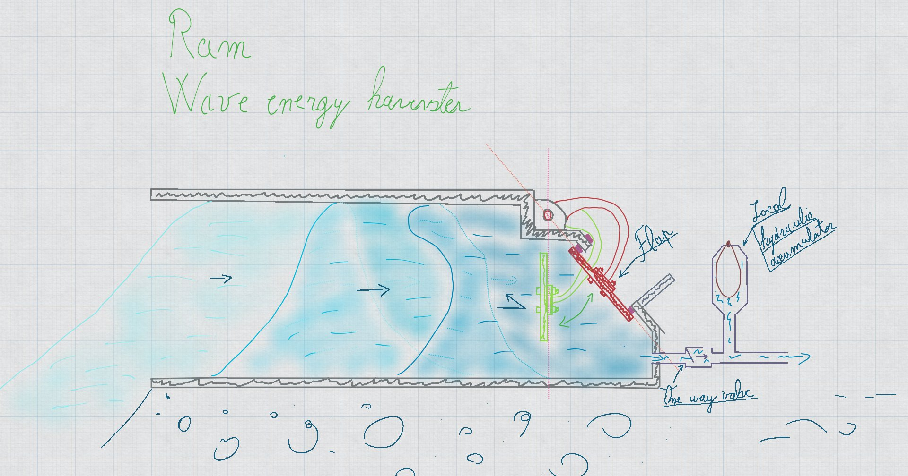
Fig. 1
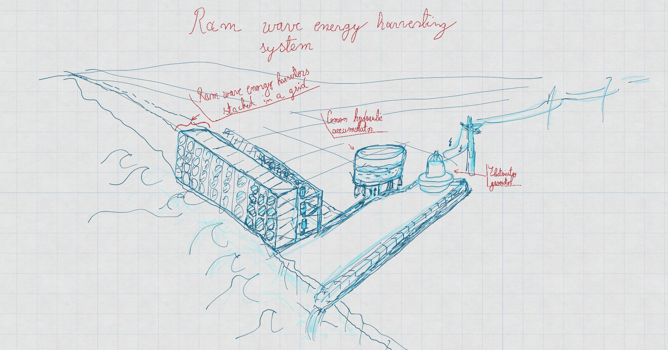
Fig. 2

